Obscured Hex. Any hex into which a figure normally cannot see but which objects may pass through. A figure may attack into an obscured hex but cannot fire through it.
Prepared Item. Any item (weapon, shield, flask, etc.) which a figure has in his hand(s) and can readily use.
Pulse. A five-second increment of game time which regulates actions while on the Tactical Display.
Ranged Zone. The hexes radiating out from a figure's front hexes into which that figure can see and fire a weapon, spell, etc.
Sheltered Hex. Any hex containing physic- al objects behind which a figure could take shelter such that approximately 50% of his body is protected from any attack.
Strike. The act of attempting to hit a hostile figure.
Strike Chance. The chance of hitting a hostile figure with a weapon; it is a combination of the Base Chance, Manual Dexterity and Rank.
DRAGONQUEST SECOND EDITION, PAGE 12

Strike Check. The roll on D100 to see if the attack was successful.
Tactical Movement Rate. A figure's Move-ment Allowance in hexes per Pulse while on the display.
Weapon. Anything used to strike a hostile figure.

10. COMBAT EOUIPMENT
To aid in the resolution of combat situa-tions, the players and the GM should have a number of items close at hand. If these items are prepared before combat begins, the en- tire process will take much less time to resolve.
The Tactical Display is used to locate and regulate the movement of the figures involved in combat. It consists of a 25mm hexagonal grid, an example of which is included in this rules book. Each hex represents 5 feet of space from side to side. A number of photocopies of this display should be made and butted together to form large areas. The GM may wish to cover

the display with a clear plastic (contact paper or acetate) to allow drawing on the display with china pencils or other erasable markers. If the players and the GM wish a detailed, rugged, 25mm hexgrid for use with DragonQuest's combat system, one is available from the publisher.
If the GM wishes to use a 1-inch square grid instead of hexes, he may, but should resolve any rules anomalies himself.
When representing figures on the display, some form of markers must be used. Often lead miniatures (available from most hobby stores) are painted to represent players' characters. Cardboard counters are equally useful, with counters being much less expensive but also much less visually exciting. Beginning players often find the three dimensional quality of miniatures helpful in visualizing what is actually occurring during combat. GM's will find that trying to collect an arsenal of appropriate monster miniatures grows to

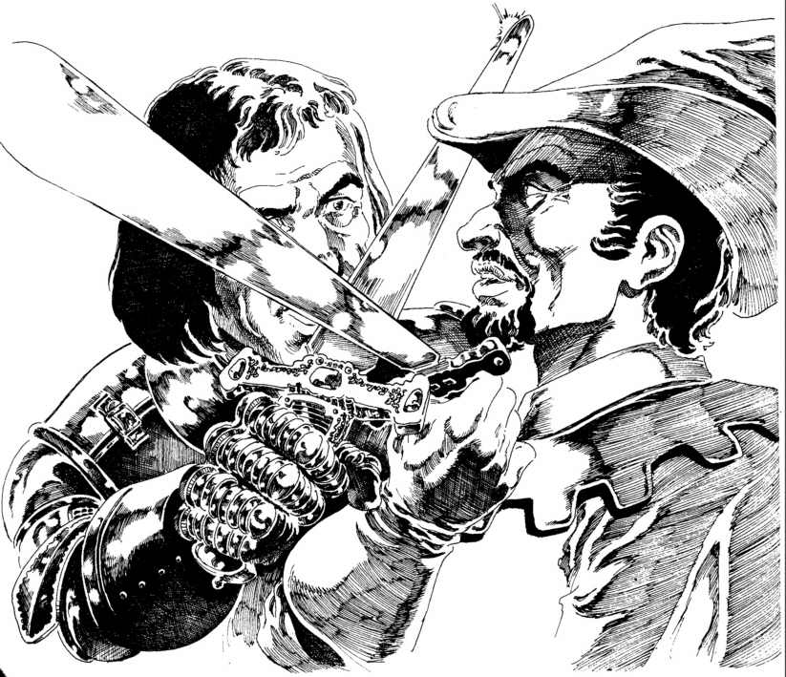

CHARACTER GENERATION & COMBAT, PAGE 13

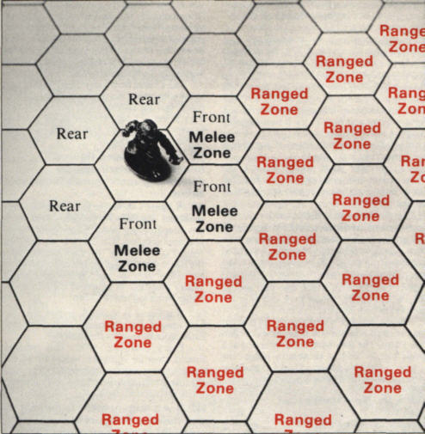

11. PREPARATION FOR COMBAT
Whenever it has been determined that combat in some form is an inevitable result of an encounter, the GM must set up all the equipment necessary for the resolution of combat (see 10.). It is important for the GM to be as organized as possible (have monsters' or NPC's characteristics and weapons pregen-erated, have miniatures or counters ready, have the encounter area mapped to facilitate easy transfer to the display, etc.) so the set-up time for combat goes quickly. Knowing combat is coming, the players will get more excited in anticipation, and now is nor the time for the GM to fumble with his notebook. Each player should have his playing piece and Character Record prepared and ready. There should be as little fuss as possible when placing pieces on the display, and the GM has the final word as to the placement of all characters, NPC's, and monsters.
If the GM has prepared the display to accept either china pencils or markers, he should draw in the details of the encounter location. This may be a hallway in a dungeon, a room in a castle, or whatever - wherever the party may encounter hostile entities is where combat may take place. If the display would be marred by drawing on it, the GM should use dice or some other form of marker to record the locations of important details. Anything the players would be able to see, touch, hear, or smell should be described to them, because inventive players will scrape for any advantage they can find, and are not above using a broken bottle, for

ILLUSTRATION 2

become inordinately expensive, and numbered counters may be used. Special monsters, painted and prepared by the GM for a particular encounter, are useful to spice up an adventure.
The GM should have a copy of a com-pleted Adventure Record and the players should have their Character Records. These contain information which will be used continuously during combat, such as strike chances, movement rates, etc. If any NPC's or monsters are involved in combat, the GM should record their characteristics and information on a piece of scrap paper or index card. This information should be determined prior to the adventure if at all possible. Any damage taken in combat should be recorded on a piece of scrap paper rather than on the Adventure or Character Records. Blank copies of these two records are included in this book.
Percentile dice are used in the resolution of combat, and plenty should be available (one pair for each player and the GM is ideal). Also, copies of all the combat charts and tables should be made so the players may readily refer to them. The GM will often use a GM screen to hide his die rolls, papers, etc., and the charts and tables may appear on it. SPI sells a screen designed for DragonQuest containing copies of all the needed combat charts and tables.

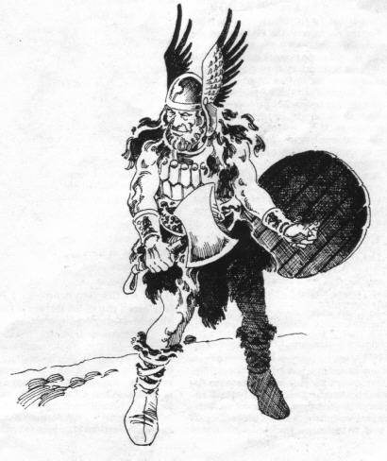

example, as a thrown weapon if they can find one. The players need to feel as if they know all the details of the encounter location they could know if they were actually there. It is the sloppy GM who suddenly realizes he hasn't told them about the small window in the northern wall just as the party is frantic- ally scrambling to find an escape route.
[11.1] Prior to placing the hostile figures on the display, the GM determines whether a surprise situation exists.
See 80.2 for the procedure to determine whether surprise exists. Once the determination has been made (this information should be conveyed to the players only if they are the ones who have achieved surprise) the GM then places the hostile figures on the display. If no surprise exists, the distance between the two parties should not be less then 8 hexes, and each group is aware of the other. If surprise does exist, the distance between the groups should not exceed 8 hexes, and can be much less depending on the GM judging the degree of "jump" one group has on the other. In both cases, the GM has the final say as to the distance separating the groups.
If surprise does not exist, Initiative is de-termined normally for the first Pulse of com- bat (see 12.2). If surprise does exist, the party with the advantage receives one "free" Pulse during which it can take any action it wishes without the surprised group being able to react. After this free Pulse, Initiative for the remainder of combat is determined normally.
[11.2] After placing all the figures on the display, the GM assigns any Fatigue losses the figures may have incurred as a result of their actions prior to combat.
For the characters, the GM should use the system detailed in 82.0. For all hostile figures, he should make a quick estimate relating all presumed activity they may have undertaken up to the instant of combat. The GM may dispense with this procedure if he feels the Fatigue loss would balance out or if he wishes to simply get on with and resolve the encounter. If he assigns penalties from one side, he must make a judg-ment for the other; he should never treat one party differently from another in this regard.
Assigning hostile figures a high Fatigue loss is one method of balancing a fight so the characters may be able to defeat a foe who, on the surface, may appear vastly superior. This does wonders for party morale.
12. COMBAT SEQUENCE
The order in which all actions are attempted in a Pulse is called the combat sequence. This sequence should be adhered to by the players and the referee as this will greatly speed play.
Each Pulse, the following events occur in order:
1. Initiative is determined for all non-engaged figures.
2. If any Melee or Close combat is possible, the GM groups the engaged figures into engage-ments, determines Initiative for each engage-ment, and resolves combat for each engagement separately prior to proceeding to the next en-gagement. Each engaged figure may choose one
DRAGONQUEST SECOND EDITION, PAGE 14

action from the list of actions allowed of engag-ed figures on the Action Summary (see 15.7).
3. The side that won Initiative in Step 1 now has the option to take action or let the other side take action. All actions of the figures on one side must be resolved before any figures on the opposing side may take action. Note: It is entirely possible for Ranged, Melee, or Close attacks to occur in this step as non-engaged figures move and attack. Each non-engaged figure may choose one action from the list of actions allowed of non-engaged figures on the Action Summary (see 15.7).
After these steps are performed, the Pulse is over and a new one begins. See 78.3 for guidelines regarding speedy resolution of combat actions.
[12. 1] A Pulse is a 5-second increment of time used to regulate all actions in combat situations.
Each action listed in Sections 13 and 14 takes one full Pulse to accomplish unless the figure performing them has an exceptional Agility (see 15.3), in which case two actions may be combined. Magic may also alter the amount of actions taken in a Pulse.
Some actions which figures in combat may wish to attempt will take far more than one Pulse. The following list is intended as a guide for the GM to be able to judge how long an attempted action will take to perform (remem-bering each Pulse equals 5 seconds):
ACTION  Search for trap in specific place  (e.g., door)  Attempt to remove trap  Quick search of 10' by 10'  room for disguised objects  Sound wall (floor, ceiling)  Search 100 square foot wall seg-ment for concealed objects  Pick Lock  Force Lock  Spike Door (per spike)  Light Torch  Light Lantern  Exchange wieldy item close to  or in hand with another being  1-handed, 1 item  1-handed, 2 items  2-handed, 1 item  2-handed, 2 items  Take off Backpack  Remove Item from Backpack  On ground  On back  Store Item in Backpack  Mount horse  Dismount horse | SECONDS  20  see 61.3  15  5  90  see 61.2  15  10  25  35  20  30  10  20  25  30  40  15  5  5
[12.2] At the beginning of a Pulse, Initiative must be determined for all non-engaged figures.
To determine Initiative, the Leader for each side rolls D10. To the result is added the Leader's Perception plus his Military Scientist Rank. The side with the highest total has the Initiative for the Pulse (any ties are re-rolled). When it becomes that side's turn to take action,

it may choose to act first or last, as it desires. That decision is made after all engaged actions have been taken.
If the Leader is involved in Melee or Close combat, Stunned or unconscious, or otherwise incapacitated, some other non- engaged figure must roll for Initiative. His Perception (only) is added to the D10 roll for Initiative. A non-leader may not add his Military Scientist Rank to the roll.
The Leader for a party is appointed prior to an adventure. An alternate may be designated, but this alternate may not add his Military Scientist Rank. If there is any doubt as to who is the current leader of a party, the GM resolves the dispute.
[12.3] For engaged figures, Initiative is determined by comparing each figure's Initiative Value.
A figure's Initiative Value is equal to his modified Agility+Perception+Rank with any prepared weapon. If the figure has no prepared weapon, it is equal to his modified Agility+ Perception. In each engagement, the figure with the highest Initiative Value may act either first or last, at his option. All others must act in order of their Initiative Value, from highest to lowest. If a figure is Stunned, or has any rear hex to-ward his opponent, the opponent automatically receives the Initiative. Every character, NPC, and monster should have its Initiative Value for all the weapons or attack forms determined prior to the adventure and recorded (for characters, on their Character Record).
[12.4] An engagement is defined as any number of figures occupying adjacent hexes, occupying the same hex, or any combination thereof.
Further judgment must be made by the GM as to the intent of each figure. For purposes of determining Initiative Values, each figure should be compared only to other figures who are involved in the same combat, or who mutually mean each other harm (see illustra-tion).
Engagements are defined to allow swift, unambiguous resolution of combat situations. The GM resolves each engagement's combat separately, and deals with the individual engagements in any order he finds convenient.
[12.5] When a figure chooses an action, it is assumed to be performing that action until it may choose again.
Thus, if a figure chose to move during the last Pulse, it is assumed to be moving for all purposes of determining combat modifiers, affects, etc.
13. ACTIONS OF ENGAGED FIGURES
Being engaged imposes certain limitations on the actions which a figure may at- tempt. A figure who is engaged is defined as one who is adjacent to a hostile figure on the display, and may have his movement and choice of action restricted. The order in which the actions of engaged figures are resolved is determined by each figure's Initiative Value, and any actions

taken by engaged figures are not simultaneous. Two or more hostile figures who occupy the same hex are in Close combat and are considered engaged.
[13.1] An engaged figure may Melee attack any figure within his Melee Zone.
If the figure who wishes to make the attack is within the defender's Melee Zone, he may move only one hex within that Zone, and change facing prior to attempting the attack. He may not move or change facing after the attack.
If the figure who wishes to attack is not within the defender's Melee Zone, he may move up to 1/2 of his TMR either before or after executing the attack. Any facing changes may be made only after the attack.
[13.2] An engaged figure may Evade.
If the figure who wishes to Evade is within the defender's Melee Zone, he may move only one hex within that Zone and change facing one hexside while executing the Evade.
If the figure who wishes to Evade is not within the defender's Melee Zone, he may move up to 1/2 his TMR and change facing as he sees fit (within the GM's discretion, see 14.l) while executing the Evade.

ILLUSTRATION 3
All three figures in Group A are engaged, as are both figures in Group B. Note that figure 4 in Group B is technically engaged with figure 3 in Group A, but the GM concluded that figure would more likely attack figure 2, whom figure 3 faces.
CHARACTER GENERATION & COMBAT, PAGE 15

If a Melee attack is attempted on a figure who is Evading, with a Ranked weapon, he may be able to Parry or Riposte (see 17.4).
Note: A figure who is Evading receives defensive benefits versus Melee and Ranged attacks (see 17.6).
[13.3] An engaged figure may Withdraw.
If the figure who wishes to Withdraw is within the opponent's Melee Zone and the opponent also occupies at least one hex of the figure's Melee Zone, the figure may Withdraw by backing directly into any of his rear hexes but may not change facing. While With-drawing, the figure may adopt one of two postures, Offensive Withdrawal or Defensive Withdrawal. If he chooses the offensive pos-ture, he may strike at his opponent (at a -20 modifier to his Strike Chance) before executing the Withdrawal. To adopt a defensive posture, a figure must have a prepared shield (ranked or unranked). While in this posture, he may interpose the shield between himself and any attack. This adds 20% to his Defense, in addition to any other modifiers already in his favor.
If the figure who wishes to Withdraw is within the opponent's Melee Zone but the

If, however, figure 4 turned his back on figure 5 to attack figure 3 in Group A, he would then become engaged with that Group. In Group C, figures 6 and 7 are engaged, even though 7 faces away from 6; in this case, 6 automatically has the Initiative.

opponent does not occupy any hexes of the figure's Melee Zone, he may move and change facing normally (see 14.1). Note: Figure #7 in the illustration on this page is an example of this situation. If the opponent is able to Melee attack the figure, the opponent automatically receives Initiative for the attack. A figure may Withdraw from one hostile figure's Melee Zone into another hostile figure's Melee Zone. If the figure wishing to Withdraw does not occupy a hex within the defender's Melee Zone, he may move normally.
[13.4] An engaged figure may take any Pass action.
If the figure wishing to Pass is within a hostile figure's Melee Zone, he may move one hex within that Zone and change facing while Passing.
If the figure wishing to Pass is not within a hostile figure's Melee Zone, he may move up to two hexes and change facing while Passing.
A Pass action is a generic term for any non-attacking action a figure may do. Typical Pass actions include: preparing an item; prepar-ing a weapon; putting an item or weapon away; picking up a dropped weapon or item; mounting or dismounting a riding beast; loading a missile; dropping to one knee or prone; rising up, etc.
All of these actions are mutually exclusive; that is no two can be attempted during the same Pass action.
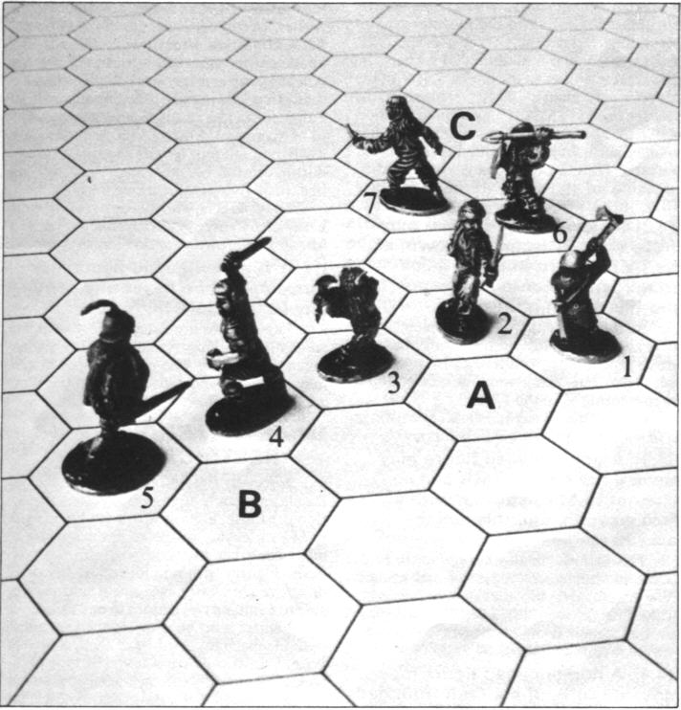
[13.5] An Adept who is engaged may attempt to cast a spell.
If the Adept wishing to cast a spell is within a hostile figure's Melee Zone, he may not move or change facing, and if attacked, will have to perform a Concentration Check (see 29.5).
If the Adept wishing to cast a spell is not within a hostile figure's Melee Zone, he may change facing after the Cast Check is per-formed. An Adept who is in Close combat may not cast a spell, but may activate Talent Magic (see 26.0).
[13.6] An engaged figure may attempt to Close and Grapple.
If the figure who wishes to Close and Grapple is within the Melee Zone of the de- fender, the defender may attempt to Repulse the attacker's Close attempt. If the defender wishes to Repulse, he rolls D10 and compares the result to his Rank with any Prepared weapon. If the result is less than or equal to his Rank, the attacker may not enter the defender's hex and must cease all action for that Pulse. If the result is above the Rank, the attacker may enter the defender's hex and execute a Grapple attack immediately.
If the figure who wishes to Close and Grapple is not within the Melee Zone of the defender, the defender may not attempt to repulse the Close attempt and the attacker may immediately enter and Grapple. Figures that are larger than one hex treat this action differently (see 22.0).
Note: Any figure who enters Close Combat must immediately drop any Prepared shield and any Prepared weapon not rated for Close combat.

[13.7] A figure engaged in Close combat may attempt to Grapple, Pass or Withdraw.
A Grapple is an attack in Close combat against any figure who occupies the same hex as the attacker. It is assumed any figures engaged in Close combat are rolling around on the ground, struggling with each other. Grappling may only be attempted with a weapon rated for Close combat.
The figure who wishes to Pass while in Close combat may take any Pass action he wishes (at the GM's discretion).
The figure who wishes to Withdraw while in Close combat must first attempt to "break contact." The figure rolls D10, and adds his (and any other friendly figures in the hex) Physical Strength and subtracts the total Physical Strength of any hostile figures in the hex. If the modified result is 10 or above, the figure may Withdraw into any adjacent hex and is assumed to be prone. In addition, an unmodified roll of 10 always allows Withdrawal
14. ACTIONS OF
NON-ENGAGED FIGURES
A non-engaged figure is one who is not adjacent to any hostile figure on the display. There are certain minor restrictions which result from this, but non-engaged figures may generally take any action they wish. All figures who are considered on the same side or members of the same party take their actions together and in any order they find convenient. In case of disagreement, the GM has final say as to the order of actions. No actions are considered simultaneous, and all actions of non-engaged figures occur after all the actions of engaged figures have been resolved.
The determination of which side acts first is resolved by the Initiative die roll (see 12.2).
[14.1] A non-engaged figure may move any number of hexes up to its Tactical Movement Rate (TMR).
A figure's TMR equals the number of hexes he may move In one Pulse, and he expends one point of the TMR for each normal, unobstructed hex he enters. For characters and all NPC's, this total is determined by their modified Agility (see 5.6). For monsters, it is listed with their other characteristics in 66 through 76.
During movement, a figure may change facing as it desires within the judgment of the GM and the fellow players. Any complicated maneuver the figure attempts may result in a penalty being applied by the GM in the form of a reduction in the figure's TMR for that Pulse. For instance, turning three hexsides (180º) within one move is a fairly complex maneuver. The GM may decide if the figure wishes to change facing to that degree, it may move two less hexes during the Pulse. At the end of movement, a figure must unambiguously face one hexside (in the case of multihex monsters, one hex vertex).
The TMR assumes a flat surface with little or no hindrance to movement. The GM is allowed to assign a penalty for movement attempted over terrain not conducive to quick traversal. In any case, a figure may always (if not
DRAGONQUEST SECOND EDITION, PAGE 16

Stunned, etc.) move one hex during a Pulse, no matter how difficult the terrain.
If a figure enters the Melee Zone of any hostile figure, he must stop movement but may change facing. If in the midst of executing a Charge and Close action, he may then be able to enter the defender's hex, depending on the results of the defender's Repulse attempt.
If a figure wishes to jump during his movement, the GM may allow this with a penalty of one hex for every 5 feet jumped (horizontally or vertically) and make the figure who jumped attempt a roll versus his Agility (with an appropriate difficulty factor) to see if he landed cleanly.
Often two (or more) friendly figures will wish to pass through a hex at the same time, or need to squeeze past another figure in the same hex. The GM must judge whether circum-stances will allow or prevent the move, and if it is hindered, to what degree. Thus, a halfling should be able to squeeze past a human without too much trouble, but for one human to move through a hex containing another human will result in at least a TMR penalty of two hexes, and possibly be disallowed if the human is currently engaged in some fairly active situation (such as preparing a bow to be fired).
A figure may crawl at a rate of 1/4 of his TMR (round all fractions down). Note: Giant characters have their TMR calculated according to the monster section pertaining to them (70.1). The average TMR listed is used as the midpoint of a chart the GM creates similar to the one in 5.6, with the appropriate giant's TMR replacing the average human TMR of 5, with modification above and below that occurring in a similar manner according to modified Agility as for humans. Thus, a Cloud Giant with a modified Agility of 19 has a TMR of 14 (average TMR of 13 + 1 for Agility = 14).
[14.2] A non-engaged figure may move up to 1/2 (rounded down) of his TMR and attempt to Melee attack with a non-pole weapon. and this action is a Charge.
At the end of the figure's movement, if he is adjacent to any hostile figure, he may Melee attack him (with a negative modifier, see 17.6). The destination hex is counted when figuring 1/2 of the TMR.
Consult the Weapons Chart for listings as to which weapons are Pole weapons.
[14.3] A non-engaged figure may move up to his full TMR and attempt to Melee attack with a Pole weapon, and this action is a Charge.
This action is in all ways similar to 14.2, except the movement is greater and using a Pole weapon gives the attacker a bonus to his Strike Chance (see 17.6). Some Pole weapons use this attack form from two hexes away (see the Weapons Chart).
[14.4] A non-engaged figure may move up to 1/2 of his TMR (rounded down) and attempt to Grapple, and this is a Charge and Close.
This action is in all ways similar to 13.6, except the charging figure has moved into the

adjacent hex from outside that hex. No facing changes are allowed during this action, and the destination hex (the hex the defender occupies) is counted when figuring 1/2 of the TMR.
[14.5] A non-engaged figure may move up to 1/2 (rounded down) of his full TMR and Evade as he moves.
The figure must obey all rules of move-ment (see 14.1) and while moving is much harder to hit (see 17.6).
If a figure who is evading while moving is Melee attacked he may (if he has a prepared Rank weapon) be able to Parry or Riposte (see 17.4).
[14.6] A non-engaged figure may move up to 2 hexes directly backward, and this is a Retreat.
The action functions in all respects as a Withdraw (13.3) except the figure may not adopt an Offensive posture since there are no adjacent hostile figures to attack.
[14.7] A non-engaged figure may fire a Missile or Thrown Weapon. or loose a Spell, and these are all Fire actions.
A figure may not move or change facing in the same Pulse as a weapon is Fired or a spell is loosed, with two exceptions: (1) once a cross-bow is prepared and loaded, a figure may carry it around and fire whenever he wishes. In this instance, movement of up to 2 hexes prior to or after firing is allowed. (2) If an Adept or his mount is flying and the Adept is in all other ways eligible to cast a spell (has his hands free, is not out of Fatigue, etc.) he or his mount may move up to 1/2 (rounded down) of his or his mount's TMR and attempt to cast the spell prior to, during or after his movement. This also applies to all flying magic-using monsters.
Only targets who occupy one or more hexes of a figure's Ranged Zone may have a Missile of Thrown weapon Fired at them.
[14.8] A non-engaged figure may move up to two hexes and perform any Pass action.
Pass actions are listed in 13.4. A figure who is Passing may also change facing while executing a Pass. The actions listed in 12.1 may require a number of consecutive Pass actions to complete.
15. ACTION CHOICE RESTRICTIONS
Normally figures occupying the Tactical Display may only attempt one permissible action per Pulse. Figures with a modified Agility of 8 or less are restricted in the amount of movement they may combine with other actions.
Figures with a modified Agility of 22 or above gain extra movement and may be able to combine two actions in one Pulse. Figures who become stunned or otherwise incapacitated will have their choice of actions drastically curtailed. The type of attack a figure may attempt against a hostile figure is limited by his position on the display relative to the hostile figure and the degree of visibility which exists.
The use of magic in combat is subject to restrictions and may in some circumstances be impossible.

[15.1] Figures with a modified Agility of 8 or less are allowed one less hex of movement when executing any of the following actions: Melee attack, Evade, Retreat, Pass, and Charge with a Pole Weapon.
Thus, Then the Dwarf, whose modified Agility is 7 due to both the weight he carries and his lack of Agility, can only move one hex while he prepares his Mattock instead of two.
[15.2] Figures with a modified Agility of 22 through 25 are allowed one extra hex of movement when executing any of the following actions: Melee attack. Evade. Withdraw, Pass, and Retreat.
Thus Eaglewing the Elf, whose modified Agility is 25 due to the lack of weight he carries, his natural Agility and his bonus due to being an Elf can move three hexes while preparing his Tulwar instead of two.
[15.3] Figures with modified Agilities of 26 and above may combine any two of the following actions in a single Pulse: Melee attack, Evade, Withdraw, Pass. Close and Grapple, Grapple. Charge, Charge and Close. Retreat, and Fire.
The actions may be combined in any order. If a figure with this option chooses not to combine two actions, it may increase its movement (as in 15.2) by two hexes.
[15.4] A figure who becomes Stunned may attempt no other action except try to recover from being Stunned.
See 19.0 for details concerning Stun and Stun recovery. A figure who becomes incapacitated can do nothing.
[15.5] A figure's choice of combat actions is limited by his position relative to the intended target of his attack.
A figure may only Melee attack a hostile figure he is adjacent to and who occupies at least one hex of his Melee Zone. A figure may only Grapple a hostile figure in the same hex. A figure may only Fire at a hostile figure who occupies at least one hex of his Ranged Zone.
If a figure is attempting to Melee attack a hostile figure who occupies a hex which is obscured (due to smoke, magic, etc.), he may attempt to strike if he first rolls less than or equal to four times his Perception on D100. If the roll is above this result, the attack may not take place and the figure may take no other action that Pulse.
[15.6] If an Adept attempts to cast a spell while either being Ranged attacked or Melee attacked, he must perform a Concentration Check (see 29.5).
This check may need to be done twice, once while Preparing the spell and once before Loosing it. If either check results in the Adept's concentration being broken, the spell may not be cast. No spell work of any kind is allowed in Close combat, but Talent Magic may be activated at any time and does not require expenditure of a Pass action to do so.
[15.7] The Action Summary lists all actions and their restrictions.
See combat charts and tables.
CHARACTER GENERATION & COMBAT, PAGE 17

16. ATTACKING
A hostile figure may be attacked by Ranged, Melee, or Close combat while on the display. To attack via Ranged combat, a figure must be armed with a Prepared weapon rated for Ranged combat and the target must occupy at least one hex of the figure's Ranged Zone. To attack via Melee combat, the figure must be armed with a prepared weapon rated for Melee combat and the target must occupy at least one hex of that figure's Melee Zone. To attack via Close combat, the figure must be armed with a prepared weapon rated for Close combat and share the same hex as the target. Note: Empty bare hands are always considered a prepared weapon.
The order of all attacking actions is deter-mined by the Initiative procedure as detailed in 12.2 and 12.3. Combat involving engaged figures is always resolved prior to any combat involving non-engaged figures. An attacker's weapon is always assumed to be held in his Primary hand (see 6.2) unless he states otherwise. Optionally, a figure may attempt to use two weapons at once, or attempt to strike more than one target with one weapon.
Special types of attacks are allowed, and these include attempting to Trip, Entangle, Restrain, Knockout, Shield Rush, or Disarm.
[16.1] A figure may attempt to attack a hostile figure he is not adjacent to via Ranged Combat by executing a Fire action.
The attacker declares his target, deter-mines and applies any Ranged Combat modifiers (see 17.6), and executes a Strike Check. The only weapons eligible for use in Ranged Combat are those rated for Ranged Combat on the Weapons Chart (see 20.2).
To fire a weapon, the attacker must have a Line of Fire (see 9.0) to the target. In addition, the attacker may fire into but not through an obscured hex. The weapon fired always travels in a straight line, and if not stopped by striking an object, it will travel 1.5 times the range of the weapon and fall to the ground.
Whenever a fired weapon enters a hex occupied by a figure (other than a solid wall, tree, or pillar which automatically breaks the weapon), there is a chance the weapon will hit the figure instead of continuing its flight. The weapon's flight is always stopped when it strikes a figure and remains in that figure until withdrawn.
A Strike Check must be resolved for all figures occupying any hex along the Line of Fire until the weapon hits something, or loses momentum and falls to the ground.
A figure may never check a Line of Fire without executing the Fire action, whether or not the weapon is actually loosed.
[16.2] A figure may attempt to Melee attack any hostile figure who occupies at least one hex of his Melee Zone.
The attacker declares his target, applies any Melee Combat modifiers (see 17.6), and executes a Strike Check. The only weapons eligible for use in Melee Combat are those rated

for Melee Combat on the Weapons Chart. The attacker may have moved adjacent to the target during that Pulse and this combination of movement and Melee is a Charge (see 14.2).
The normal melee attack is intended to do as much damage to the target as possible, but other forms of specialized attack exist and are detailed in 16.5.
[16.3] A figure may attempt to attack any figure who occupies the same hex only via Close combat by executing a Grapple action.
The attacker declares his target (there may be more than one figure in the hex), applies any Close Combat modifiers (see 17.6), and executes a Strike Check. The only weapons eligible for use in Close combat are those rated for Close combat on the Weapons Chart. The attacker may have moved into the target's hex during that Pulse, and this combination of movement and Grappling is detailed in 13.6 and 14.4.
[16.4] A figure who is armed with either two prepared weapons or one two-handed class B weapon may attempt a Multiple Strike.
A figure may attempt to strike one or more targets more than once as part of the same attack with two different weapons (one in each hand), but suffers a negative attack modifier (see 17.6). The attacks need not be directed at the same hostile figure, but must be of the same type (Grapple, Melee, or Fire). Some non-humanoid monsters could attack 3, 4, or more times in one Pulse using this option.
A figure may attempt to strike more than one target one time each if the prepared weapon is Class B and the attacker is Rank 4 or above with the weapon. Each figure thus attacked must be in adjacent hexes within the attacker's Melee Zone. Thus, the maximum number of attacks available via this option is three. This attack may only occur in Melee Combat, and the attacker suffers a negative attack modifier (see 17.6).
[16.5] A figure attempting to attack may specify any one of the following special attacks:
Trip. The attacker must be armed with a Quarterstaff, Spear, Halberd, Poleaxe, or Glaive and be in Melee Combat. The Base Chance is 40% and the damage is D10. If the attack is successful, the target must attempt to roll less than or equal to 3 times his modified Agility. If the target's Agility roll is successful, he keeps his footing; if he fails the roll, he falls prone. This only works against human size or smaller targets.
Entangle. The attacker must be armed with a Net, Whip, or Bola. The Base Chance is listed with the individual weapons. If entangled, the target suffers D10-4 damage. If the attack is successful, the target must attempt to roll less than or equal to 3 times his modified Agility, falling prone if he fails. The target must disentangle himself before rising, and to do so requires the target to execute a Pass action for two consecutive Pulses.

Restrain. A figure may attempt to restrain another figure by executing a Grapple. A successful attack results in the hostile figure being restrained (pinned). The Base Chance equals the Physical Strength plus modified Agility of the attacker minus the Physical Strength plus modified Agility of the target, times 3. No damage is done to the target. A restrained figure is treated as incapacitated, and remains restrained until the hold is broken by an attack from outside the hex which does at least one point of effective damage to the restrainer. Several figures may combine their PS and AG to attempt to restrain a hostile figure.
Knockout. The attacker must be armed with any weapon except Missile Weapons, Entangling Weapons, Darts, Grenades, Lances, or Pikes. The attack is successful if the Strike Check result is equal to or less than (l5% of the modified Strike Chance). No damage is done and the target is knocked unconscious for D10+5 minutes, with the results of the time roll being kept from the players. Note: The Sap is a weapon especially designed for this purpose and is detailed on the Weapons Chart (see 20.2). This attack may not be attempted on larger than human sized monsters.
Shield Rush. The attacker must be armed with any shield except a Main Gauche or Tower Shield. The Base Chance is 40% and the damage is D10-2. Rank with the shield will increase the Base Chance as with any weapon. If the attack is successful, the target must attempt to roll less than or equal to 3 times his modified Agility, falling prone if he fails. If this attack is occurring at the termination of a Charge attack, the Base Chance is increased by 20.
Disarm. The attacker must be armed with any weapon rated for Melee or Close com bat. 20 is subtracted from the modified Strike Chance before the attack is resolved. If the attack is successful, the target is forced to drop one weapon or item of the attacker's choice and also 1 point of Endurance damage is done to the target.

17. RESOLVING ATTEMPTED ATTACKS
Every weapon and attack form is assigned a Base Chance. This percentage chance may be modified due to weapon skills, attack type, posture of the combatants, defense of the target, etc. The Base chance with all modifiers applied is the Modified Strike Chance. The attacker rolls D100; if the result is less than or equal to the Modified Strike Chance, the attack has been successful; above and the attack has missed. Rolling a 99 may result in the weapon being broken and rolling 100 may result in the weapon being dropped. Once a successful hit has been made, a Damage Check is conducted.
If the target is Evading, the attacker suffers a negative modifier to his Strike Chance and, if he misses, his swing may have been Parried, leading to a Disarm or Riposte.
[17.1] The Strike Chance of an
attacking figure is a combination of the Chance of the weapon or attack DRAGONQUEST SECOND EDITION, PAGE 18

form plus modifiers for Rank and
Manual Dexterity.
To attack with any Ranked weapon, the Strike Chance is (Base Chance of Weapon) + (Modified Manual Dexterity)+(4 x Rank). To attack with any unranked weapon, the Strike Chance is equal to the weapon's Base Chance unmodified. The Strike Chance of either a Ranked or unranked attack will be further modified (see 17.6).
In any natural attack form such as teeth, claws, etc., for monsters, their Manual Dexterity plus 4 times Rank (if any) is always added. For all characters and other figures, the Strike Chance should be calculated prior to an adventure and recorded on the Character Record.
[17.2] An attacker's Modified Strike Chance is equal to its Strike Chance minus the target's Defense plus any modifications for attack type and attack conditions.
If the attacker rolls less than or equal to the Modified Strike Chance, a successful hit has been scored and a Damage Check must be performed (see 18.0).
Attack types include Ranged, Melee, and Close combat. Attack conditions include lighting conditions, which hand the weapon is used in, and other miscellaneous modifiers.
[17.3] Whenever the Strike Check results in a roll of 99 or 100. the attacker may have either dropped or broken his weapon.
If the roll is 99, the attacker may have broken the weapon; on 100, the attacker may have dropped his weapon. In either case, the attacker then rolls D100: if the roll is less than or equal to 3 times his modified Manual Dexterity, he has avoided either misfortune. If the roll is above his modified MD, the misfortune occurs.
A dropped weapon may be picked up by any figure at any later time, but a broken weapon may not be used. When this result occurs to an attacker to whom it would not apply (a dragon's teeth really cannot be dropped), the GM may, at his option, announce the attacker has fumbled and may not attack the next Pulse due to his clumsiness.
[17.4] Whenever the Strike Check result is 30 or more above the Modified Strike Chance, the target may have Parried the attack.
Only figures who are currently Evading and are being Melee attacked may Parry. The defender rolls D10, adds the Rank of any prepared weapon, and subtracts the Rank of the attacker's weapon. If the result is 3 or less, the attack has been successfully Parried; but in so doing, the defender has been thrown off balance and must execute a Pass action next Pulse. If the modified result is 4 through 7, the attacker has been Disarmed per the attack of the same name (see 16.5). If the modified result is 8 or above, the attack has been Parried to the extent that the attacker has become Disarmed and the target may execute a Melee attack instan-taneously against him without need to perform

an attack action. This is called a Riposte. A Riposte may never itself be Parried and may occur as many times during a Pulse as the evading target was Melee attacked. A target may even Parry attacks which do not come through his Melee Zone (e.g., from behind him). An unarmed figure may Parry if he is Ranked in Unarmed Combat (see 21.0).
[17.5] A figure's Defense Rating is a combination of his modified Agility plus any defense afforded by a prepared shield.
A figure's Defense Rating is subtracted from an attacker's Strike Chance. The defense of a shield is a function of the Rank the target has with the individual shield types (see Shield Chart). Thus, a figure with a modified Agility of 13 and Rank 3 with shield carrying a Large Round Shield has a Defense Rating of [13 + (3 x 4%)] = 25%, and this is subtracted from any attacks coming through any of the figure's Melee Zone hexes. If the attack comes through any of the figure's rear hexes, the addition of the shield defense is ignored, but the modification for Agility re mains in effect.
Optionally, the shield defense may only be included for attacks which come through the target's front hex and the hex facing the side of the target in which the shield would actually be carried (normally in the target's secondary hand).
The Defense Rating is not subtracted from any attacks if the defending figure is Stunned or incapacitated. Also, any shield defense is ignored for Close combat. Any shield except the Main Gauche is automatically dropped upon entering into Close combat.
[17.6] Each attack type (Ranged, Melee, or Close) has its own list of Strike Chance modifications.
After calculating the attacker's Strike Chance and subtracting the defender's Defense, the Strike Chance Modifiers Summary should be consulted to see if any situations exist which could further modify the Strike Chance.
Example: Rolf the Barbarian is Melee attacking the White Mouser, a lithe figure with high Agility. Rolf is using a broadsword (which he wields at Rank 3), and has a modified Manual Dexterity of 15. The Mouser has a modified Agility of 18 and is using a Main Gauche (which he wields at Rank 2). Rolf's Strike Chance is [55+15+(3x4%)]= 82%. The Mouser's Defense Rating is [18+ (2x2%)]=22%, which is subtracted from Rolf's Strike Chance since he is attacking the Mouser through the Mouser's Melee Zone (if he was attacking him through one of his rear hexes, the 4% extra for the Main Gauche would not count and the Defense would be 18%). But, furthermore, the Mouser is kneeling (a +20 from the Melee Combat Modifiers Chart), so receives a Modified Strike Chance of 82-22+20 = 80%.

[17.7] The charts listing modifiers used in calculating the Modified Strike Chance of any attack include the Shield Chart. Ranged Combat Chart. Melee Combat Chart, Close Combat Chart,

Lighting Conditions Chart, and the Miscellaneous Conditions Chart.
See the Strike Chance Modifiers Summary for these listings. Although these listings may appear lengthy, few are used very often, and those will be committed to memory after a few melees. The GM is encouraged to invent any other modifiers he sees fit to add in any combat situation. He is the final arbiter as to what modifiers are used and when they apply. Any situations not specific ally covered by these listings must be judged individually by the GM.

18. DAMAGE
Whenever a figure is hit by a weapon or magic, a Damage Check is performed. Each attack type has a damage modifier which is added to a D10 roll, and the result is the amount of damage points inflicted on the figure. Armor may absorb some or all of the damage up to the armor's Protection Rating, and any damage points not absorbed are inflicted on the figure and subtracted from either Fatigue or Endurance. Any damage points actually inflicted on the figure (not absorbed by armor) are termed Effective Damage.
There are three types of damage possible from a successful strike, depending on how low the attacker rolled on the Strike Check: Damage affecting Fatigue; affecting Endurance; and Grievous Injury. When the Strike Check result is above 15% of the Modified Strike Chance, any effective damage is subtracted from Fatigue (Endurance when Fatigue reaches 0). When the Strike Check is 15% or less of the Modified Strike Chance, any damage directly affects Endurance and is not absorbed by armor. If it is 5% or less of the Modified Strike Chance, a Grievous In jury may also result, in addition to Endurance damage. These percentages are summarized on the Special Damage Chart (18.2).
Any Damage Checks modified to a result less than 1 are treated as 1.

[18.1] Damage affecting Fatigue is absorbed by armor.
Each type of armor has a Protection Rating, which indicates the amount of damage points subtracted from every successful attack. When a figure's Fatigue reaches 0, any further damage affecting Fatigue is subtracted from Endurance in stead. However, a figure cannot lose Fatigue and Endurance as a result of a single Strike Check.
Example: Rolf is wearing Leather armor (Protection Rating of 4) and has 3 Fatigue Points remaining. An attack against him results in 9 total damage points. The Leather absorbs 4 of those, and normally the remaining 5 would be subtracted from Fatigue. But, since he only has 3 Fatigue Points left, he loses 3 Fatigue Points and the rest are ignored entirely. If any further attacks result in damage being subtracted from Fatigue, the Leather would still absorb 4 points of that damage, but any remaining points would be subtracted from Endurance instead.
The Armor Chart lists all types of armor and their Protection Ratings. The GM should feel free to invent other types of armor if he wishes.
CHARACTER GENERATION & COMBAT, PAGE 19

[18.2] A Strike Check of 15% or less of the Modified Strike Chance results in damage directly affecting Endurance which is never absorbed by armor, and the stricken figure always takes the full amount of the damage.
The Special Damage Chart lists modified Strike Chances and their damage directly affecting Endurance range.
[18.3] Grievous Injuries may result if the successful Strike Check is 5% or less of the Modified Strike Chance.
If a possible Grievous Injury has resulted, the damage to Endurance is first calculated and applied. The attacker then rolls D100 and consults the Grievous Injury Table. If the roll falls within the range specified for the class of weapon he is attacking with, a Grievous Injury has resulted and the effects of the resulting injury are applied to the unfortunate target immediately. If the roll falls outside the indicated range, no Grievous Injury occurs.
Weapons are classed on the Weapons Chart (see 20.2) according to type: thrusting weapons are Class A; slashing weapons are Class B; and crushing weapons are Class C. The Grievous Injury Table lists the ranges for each class of weapon. A figure may suffer any number of Grievous Injuries in a Pulse.
Whenever a figure suffers a Grievous In jury, there is a possibility he has dropped whatever he is holding, and the procedure outlined in 17.3 is used to resolve this occur-rence.
A figure who suffers a Grievous Injury while wearing armor has the Protection Rating of that suit of armor reduced by 2 until repaired. Optionally, a figure who is also carrying a shield can choose to have the shield cloven and spare his armor. A cloven shield is useless.
[18.4] Damage incurred as a result of a magical attack is applied differently.
Many spells attack figures with purely magical energy, while others inflict damage as a result of changes in the physical surroundings of the target (windstorms, falling rocks, and the like). When purely magical energy is involved, any damage is subtracted first from Fatigue (Endurance only when Fatigue is exhausted), but is not absorbed by armor. Other damage types, also subtracted from Fatigue, are absorbed by armor.
When being attacked by the breath weapon of a monster, treat the damage as if magical energy, as above, but allow every target a Passive resistance roll before applying the damage. If the target does Passively resist, the damage is halved (round fractions down). No Active resistance is allowed versus breath attacks.
[18.5] (Optional Rule) The damage done with a particular weapon may be increased due to exceptional Physical Strength or Rank.
If using this rule, add 1 to the damage modifier of a weapon for every 5 points of Physical Strength above the minimum neces-sary to wield the weapon the attacker possesses. Thus, a figure with PS of 20 through 24 would

do D+5 damage when wielding a Broadsword. However, for every +1 of damage the figure receives, an extra 6% is added onto the chance of the weapon breaking during combat. The above figure with the PS of 20 would have a chance to break the Broadsword on rolls of 93 through 99, inclusive. This increase in breakage chances precludes any Modified Strike Chances which would conflict with it. Thus, if the above figure had a Modified Strike Chance of 97%, it would actually be 92% since rolls of 93-99 would result in a possible break and 100 would result in a possible drop. This does not apply to Thrown or Missile Weapons.
If wishing to allow increased damage for Rank attained with a weapon, give a +1 bonus for every 4 Ranks (round down). This rule will increase damage down by Thrown or Missile Weapons, and does not increase breakage chances. It is recommended only one of these systems be used with any one particular weapon, not both.
19. THE EFFECTS OF DAMAGE
The ultimate result of incurring damage for any figure is death; this arrives when the figure's Endurance reaches 0. When figure's Endurance reaches 3, he falls unconscious, and can only be revived by time or the arts of a Healer.
Whenever a figure suffers effective damage greater than one third his original Endurance from a single strike, he becomes Stunned. The figure may not take any other action except attempt to recover from Stun until he has recovered. A figure who becomes Stunned may drop anything he is holding. (The procedure outlined in 17.3 is used to resolve the outcome. The check is only performed once, at the moment the figure becomes Stunned.)
A Stunned figure who is engaged automatically has the lowest Initiative Value of the engagement; an unengaged Stunned figure acts the last of all his fellows.
To recover from being Stunned, a figure must roll less than or equal to 2x his Willpower plus his current Fatigue.
Current Fatigue is the figure's Fatigue total at the instant the roll is made. Every Pulse after becoming Stunned, the figure may attempt to recover but may do nothing else, including move.
Note: Certain monsters begin with an Endurance of 5 or less. These monsters never become unconscious; they are either alive and alert, Stunned, or dead.
20. WEAPONS
Any instrument used to inflict damage on a figure is called a weapon. Weapons may include the figure's hands, claws, talons, feet, teeth, breath weapon, etc. All normal weapons are listed on the Weapons Chart along with their characteristics. The only limits to the number of weapons a character may have in his possession are the weight and bulk of those weapons. The GM should carefully examine each character, checking for the location of the character's weapons. Any odd or unlikely method of carting weaponry around should be disallowed. Any humanoid figure may never have more than two

one-handed weapons or one two-handed weapon prepared at any one time. Carrying a prepared shield replaces one one-handed weapon and disallows a two-handed weapon for this purpose. Figures with more than two appendages may use as many weapons as they are able. It is always assumed when a figure is armed with a one-handed weapon it is carried in his primary hand unless stated otherwise.
A figure may attempt to envenom any A or B Class weapon and thus poison the figure it strikes. An assassin is trained in the use of envenomed weapons (see 20.3).
[20. 1] A figure need not use any normal weapon to attack.
A figure may attempt to strike barehanded (see Unarmed Combat, 21.0), but only if one hand is free. Any figure may attempt to use an item not normally assumed to be a weapon (furniture, books, glasses, dishes, etc.) at the GM's discretion, who assigns Base Chances, damage modifiers, and so forth.
[20.2] The Weapons Chart lists an normal weapons and their characteristics.
All normal weapons which would appear within a common DragonQuest world are detailed on the chart. If the GM wishes to add more exotic weapons to the list, he should feel free to, and should assign characteristics for those weapons based on the examples given. The characteristics for each weapon are:
Weight. The weight of the weapon in pounds (or ounces, if so noted).
Physical Strength. The minimum Physical Strength a figure needs to wield the weapon properly; a figure without the PS to meet this minimum does one less point of damage for each point of strength he is below the minimum. A figure may never achieve Rank in a weapon he does not have the PS to wield.
Manual Dexterity. The minimum modified Manual Dexterity a figure needs to maneuver the weapon properly; a figure without the MD to meet this minimum has the Base Chance of the weapon lowered by 5 for every point he is below the minimum. A figure may never achieve Rank in a weapon he does not have the MD to maneuver.
Base Chance. The base percentage of the weapon to score a successful hit on a figure.
Damage Modifier. The number added to the D10 die roll when performing a Damage Check; the modified total may never be less than 1.
Range: The distance, in hexes, the weapon may be fired. P means prohibited.
Class. A letter representing the type of damage done by the weapon. A weapons do thrusting damage. B weapons do slashing damage. C weapons do crushing damage. Used for determining Grievous Injuries.
Use. A letter representing the type(s) of attack the weapon may be used in. R indicates Ranged combat. M indicates Melee combat. C indicates Close combat. A weapon may not be used in an attack type for which it is not rated.
Cost. The cost, in Silver Pennies, to purchase the weapon. At the cost listed, the weapon is of normal quality.

DRAGONQUEST SECOND EDITION, PAGE 20

Maximum Rank. The highest Rank attainable with that weapon.
[20.3] Figures may, at the GM's discretion, employ envenomed weapons.
If the GM permits, figures may carry and use weapons coated with poison. Only Class A and B weapons may be envenomed. See the Alchemist skill for details concerning types of poisons and paralysants. For the venom to be introduced into the bloodstream of the victim, at least 1 point of effective damage must be done.
When anyone but an Assassin handles an envenomed weapon, there is a chance the figure will nick himself and introduce the venom into his own bloodstream. Every time an envenomed weapon is handled, the figure must try to roll less than or equal to 3 times his modified Manual Dexterity on D100 to avoid any mishap. If the roll is greater than his MD, he has been nicked by the weapon and is poisoned. Handling a weapon is defined as including all actions of coating the weapon with the venom, storing the weapon until use, and preparing the weapon for the attack. The check should be made once for the preparation of the weapon and once for the attack. The timing of
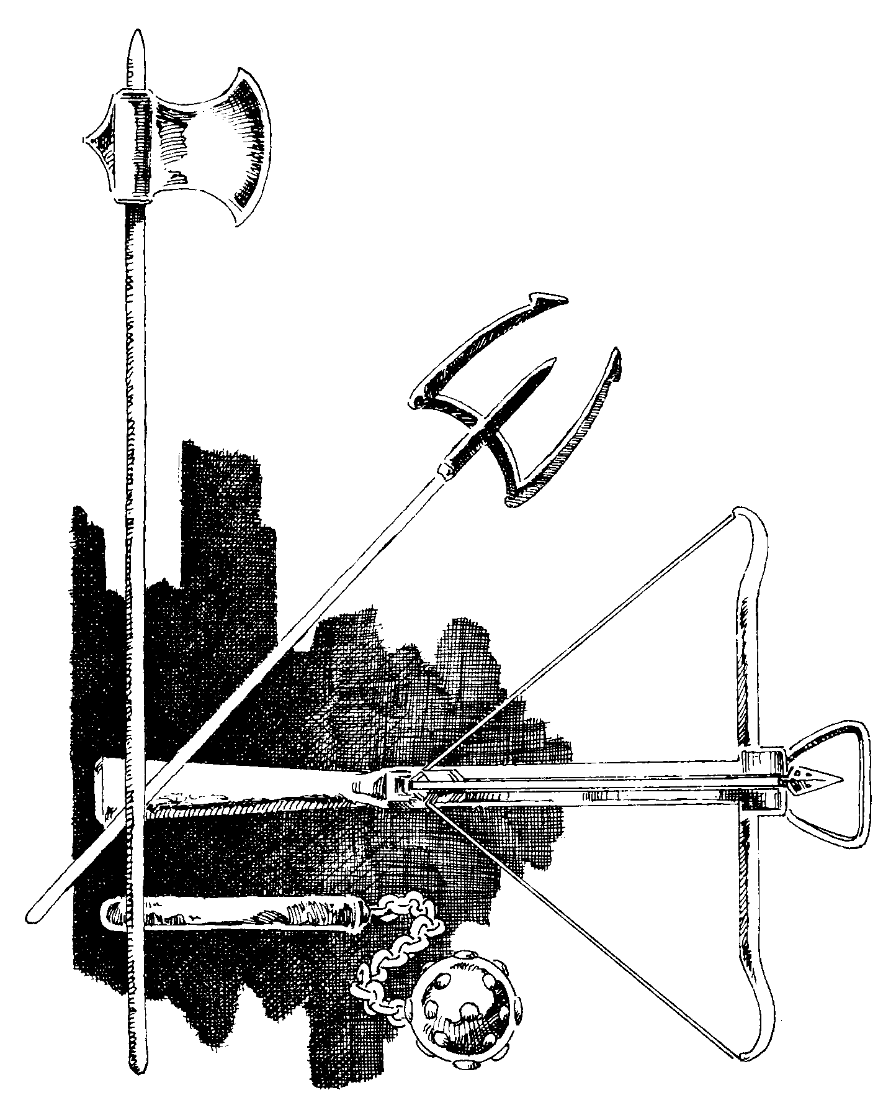

the checks is up to the GM, but two rolls should always be made if the weapon is used to attack. Cleansing the weapon of the poison does not require a check. An envenomed weapon will remain effective for 6 hours, by which time the venom will have evaporated or been wiped off. When the weapon has successfully struck and done 1 or more points of effective damage, the venom has been removed.
A paralysant functions as a knockout drug against human-sized or smaller figures. If the victim fails his Willpower Check (see 50.8), he falls prone unconscious and will remain that way for [20+D10-(His Willpower)] minutes.
[20.4] A figure struck by a Class A missile or thrown weapon will have his Agility lowered until the weapon is removed.
Whenever a figure suffers effective damage from a Class A Missile or Thrown weapon, it has lodged itself in the target's body and reduces his Agility by 3. The weapon remains lodged until a Pass action is executed to remove it. When any barbed weapon is removed (arrow, spear, etc.), the figure takes D-4 damage to Fatigue (not absorbed by armor). If the weapon is a Pole weapon, the Agility loss is 5 and the damage to remove it is D-2.

The Agility loss applies only to man-sized or smaller figures. The GM must judge the Agility loss for larger figures.
21. UNARMED COMBAT
Any figure may attempt to attack a hostile figure by using his hands and feet. For many monsters, this is the only way they may attack. Unless specified otherwise, all figures/monsters receive one attack with their hands/claws/bite per Pulse without penalty. Some monsters may be able to attack more than once, and these individuals are detailed in the Monsters Section (VIII).
For a humanoid figure to strike with his primary hand, the Base Chance is (modified Agilityx2). For every point the figure's Physical Strength is above 15, the Base Chance is increased by 1. The damage done by a successful strike is D-4, with 1 extra point of damage for every 3 points of Physical Strength above 15. A humanoid can achieve Rank with bare hands just as he can with any weapon.
Beginning at Rank 3 in Unarmed Combat, figures may choose to kick instead of using hands (or in addition to hands) in unarmed attack. This allows an unarmed attack while a figure's hands are full. The Base Chance and damage are as above. Using legs in this manner allows an attempted Trip by the attacker (see 16.5) with Base Chance and damage remaining the same as for all unarmed combat.
22. MULTIHEX MONSTERS
Many monsters detailed in the Monsters Section (VIII) will occupy more than one hex on the Tactical Display. Their size necessitates the
CHARACTER GENERATION & COMBAT, PAGE 21
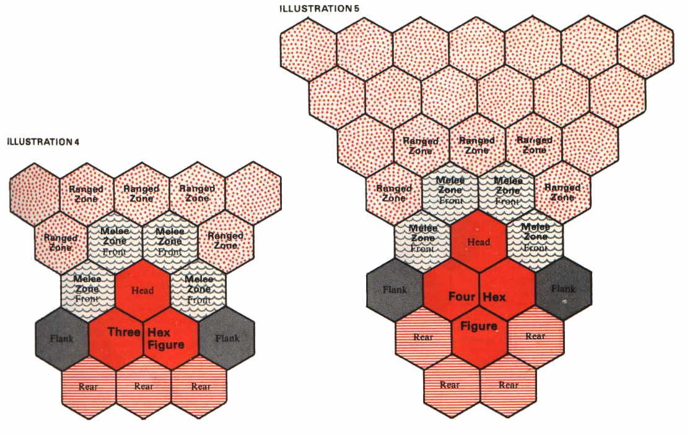

following alterations in the resolution of movement and combat.
Multi-hex monsters have three types of hexes surrounding them: Front, Rear, and Flank. Front and Rear hexes function in the same way for them as for any other figure, but attacks through Flank hexsides give the attacker a bonus (see 17.6). The exact configuration of Front, Rear, and Flank hexes vary with the size of the monster (see illustration).
A multi-hex monster must always be placed on the display such that its head unambiguously faces a vertex of two hexsides. It may move in any way so that its head enters any Front hex, and may move up to its full TMR in this fashion. At the end of its movement, it must once again unambiguously face a vertex. For facing changes, a penalty of one less hex of movement for each two hex vertices changed is applied, since the mass being maneuvered is much greater than a humanoid's. In order to change facing, the monster must pivot using its head as the pivot point.
A multi-hex monster may freely pivot or move into any hex occupied by a 1-hex figure. The smaller figure is knocked prone automatically and the monster may then attempt to trample the figure at a Base Chance of 40%, doing (D10 + size of the monster in hexes) damage. Trampling is Class C damage.
See illustrations on this page and22.
23. MOUNTED COMBAT
In mounted combat, the TMR of the figure (comprising the mount and the rider) is that of the mount; the rider may not move at all. A

rider may only mount or dismount when the mount is not moving. Any action a figure is capable of while standing on the ground he is capable of while mounted with the following exceptions: (1) using a two-handed weapon; (2) firing any missile or thrown weapon while moving; (3) using more than one weapon at a time. These restrictions are lifted depending on the Horsemanship Rank of the rider (see 83.2). A figure may always use a shield and a one-handed weapon while mounted.
ILLUSTRATION 8
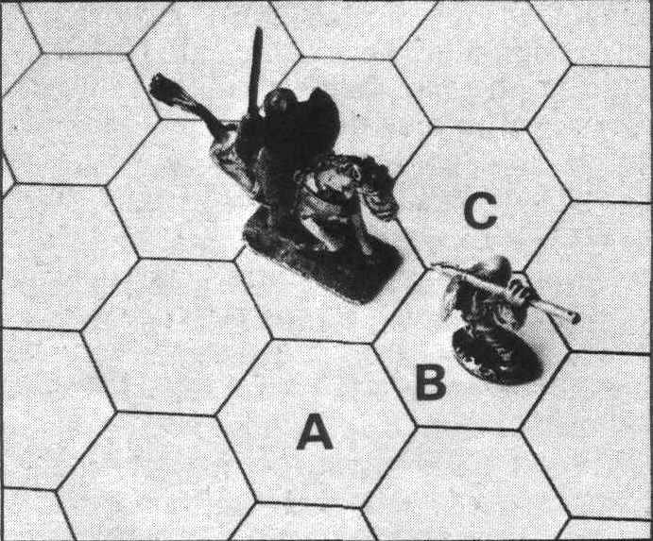
The horseman with the sword can attack into hex A or hex C, but not into hex B. Thus, the figure on foot cannot be hit with the sword, but he could be trampled.
A rider and mount will normally occupy only one hex, unless the mount is a multi-hex monster. If they occupy more than one hex, the movement will be governed by the rules of multi-hex monsters (see 22). On a normal mount, the rider will not be able to attack out

of his Front hex, only the hexes to either side of that hex. His Front hex may be attacked into using a spear (or similar long hafted weapon) or any Fired weapon (see illustration).
To control a mount during combat, the Horsemanship skill of the rider is taken into account. An inexperienced horseman will have an incredibly difficult time even con-trolling his mount in a chaotic melee; it will be better for him to dismount and fight on foot until he becomes skilled.
A Charge on a mount is executed in the same manner as a Charge on foot except the amount of movement prior to the attack will be greater and the Charge must be in a straight line (no facing changes allowed). Any act of turning the mount or stopping it during or after the Charge will require a Horsemanship Check (see 82.2). The Pulse following any mounted Charge,

DRAGONQUEST SECOND EDITION, PAGE22

the momentum will take the mount past the target to its full TMR. Any attempt to turn or stop the mount will occur after that movement is terminated. A failed check will result in the mount continuing on its way.

24. INFECTION
At the end of every combat in which a figure is wounded, or when a figure is wounded in a non-combat situation, there is the possibility that figure has become infected as a result of their wound. An Infection Check is performed to determine whether the figure is infected or not.
The Base Chance of infection is equal to 10%. If the figure took any damage to Endurance, add (20 + the amount of Endurance damage in points). If the damage was inflicted by bite, claws, or talons, add 20. Specific

Grievous Injuries can raise the Base Chance even further. The infected figure rolls Dl00; if the result is greater than the modified Base Chance, the figure is not infected; if the result is equal to or less than, the figure is infected.
An infected figure is considered diseased, and every morning after becoming infected, the figure must try to heal himself or suffer Endurance damage. To heal himself, a figure must roll under his original Endurance on Dl00; a roll equal to or less than the Endurance results in a cure. If the infection is not cured, each day the figure takes D10-5 (minimum result of 1) Endurance damage from the infection. Obviously, an infected figure who is not cured will eventually die from his wounds. The effects of slow acting (blood agent) poisons function in the same manner as infections except there is no roll for cure.

